Dear Parents/Carers of Year 6 pupils,

The following schools have open events which do not need to be booked. Please take the opportunity to look at the schools with your child and have a look on the school websites.

Bishop Stopford School.
www.bishopstopford.com
01536 503503
Thursday 12th October 2023. 5.30pm-8pm

Latimer Arts College.
www.latimer.org.uk
01536 720300
Thursday 5th October 2023. Starting at 5.30pm

Southfield School for Girls.
www.southfieldsch.co.uk
01536 513063
Tuesday 26th September 2023 starting at 5.45pm

Kettering Buccleuch Academy.
https://kba.uk
01536 515644
Thursday 28th September 2023 starting at 5.45pm

Kettering Science Academy.
www.ketteringscienceacademy.org
01536 532700
Tuesday 10th October 2023 from 6pm.
In addition, Bishop Stopford has some open mornings which need to be booked these are week commencing 9th October and need to be booked using the link on the website.

Once you have decided on the secondary school you prefer you will need to complete this online using the following link. You can state three preferences.

Apply for a secondary school place | North Northamptonshire Council (northnorthants.gov.uk)
You need to complete this application by 31st October 2023.

Please be aware that some school have a second application which needs to be submitted direct to the school, such as Bishop.

We hope that you find this information useful.

Kind regards
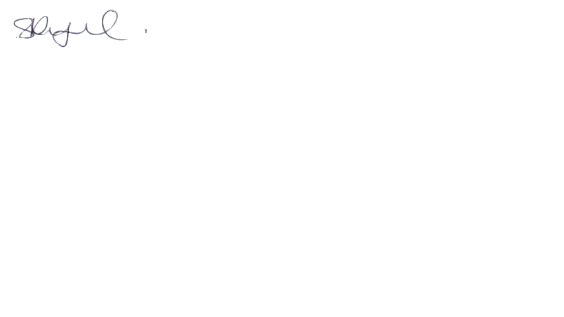
S Reynolds
Principal

