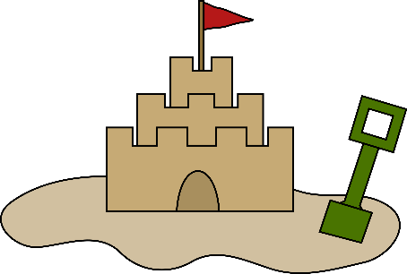
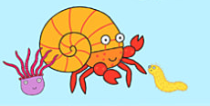




Maths

The children will develop early mathematical skills through play and everyday experiences. They will explore concepts such as counting, quantity, and number recognition using songs, stories, and hands-on activities. Opportunities will be provided to compare sizes, notice patterns, and begin to understand shapes and space through building, sorting, and exploring their environment. Children will also develop problem-solving skills as they investigate cause and effect, use simple language related to maths (such as “more,” “big,” and “full”), and begin to make sense of numbers in meaningful contexts.

All children are working towards the Engagement/Pre Key Stage/EYFS curriculum, and some may access this learning more directly; please see their individual year group theme overview for further information on specific learning experiences and coverage.
Expressive Arts and Design

Children will explore a range of creative and imaginative activities to support all learners. They will develop pencil control skills by drawing seaside pictures. They will join materials together to create a lighthouse, exploring the most effective ways to connect materials and selecting appropriate resources. Children will also create collages, experimenting with a variety of textures to represent seaside scenes. In addition, they will learn and join in with nursery rhymes, using actions, sounds, and repetition to develop expression, communication, and engagement.

Personal, Social and Emotional Development

The children will develop their personal, social, and emotional skills through play-based activities that support all learners. They will be encouraged to build relationships, explore their emotions, and develop confidence in a safe and supportive environment. Children will be supported to express their needs and feelings using their preferred communication methods and will begin to develop independence through everyday routines and interactions with others.
R.E

Focus: What places are special and why?
This half term the children will think about places that are special to them and consider they why they are special. (May be Grannie’s house, or under the bed!)
Physical Development

The children will develop physical skills through play-based activities supporting both verbal and non-verbal learners. They will build gross motor skills through climbing, balancing, and outdoor play, and fine motor skills through mark-making and handling objects. Children will also be supported to develop independence in self-care using their preferred communication methods. They will also practice working as a team navigating an obstacle courses, balancing and running in preparation for sports day.

English

The children will develop early English skills through stories around the sea, such as The Lighthouse Keeper’s Lunch, Deep Sea Diver, Winnie and Wilbor go to the beach, Kipper at the Seaside, Commotion in the ocean, Sharing a shell and Rainbow fish. They will join in with repeated refrains, anticipate key events, and use their preferred communication methods to talk about characters and storylines.
I wonder what you can find at the seaside?
Children within the Sunshine room receive bespoke learning experiences tailored to meet their individual needs, interests, and stages of development. As every child learns at their own pace, activities are carefully adapted to ensure all children can access and engage with the learning at an appropriate level. Practitioners support and extend each child’s understanding through differentiated opportunities, enabling them to build confidence and progress in their own unique way.
Understanding of the World
The children will develop their understanding of the world. Watch videos about the seaside. Find out what happens there. They will explore different modes of transport and explain which transport would be best to get from place to place. Discuss the seasonal changes of Summer and explore how to help protect the world – looking after creatures and flowers, and by looking after our environment.
Communication and Language

The children will develop communication and language skills through tailored, engaging activities that support both verbal and non-verbal learners. They will join in with repeated refrains, rhymes, and stories using words, sounds, or communication aids. New vocabulary will be introduced and reinforced through visuals and repetition. Children will also be supported to retell familiar stories during play using their preferred method of communication.
Sunshine
Summer 2

