
St Mary’s C.E. Primary School

Once your child has been enrolled at our school we will be able to provide your child with a Teams login. It may take up to 2 weeks to obtain this but it is important when received to make sure you can access your child’s Teams account at home.

Please see instructions below:

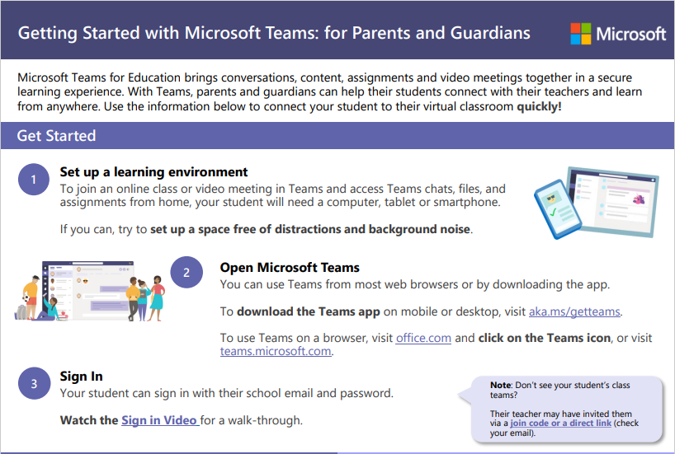

This is the link below for the Sign In Video mentioned above:

https://www.microsoft.com/en-us/videoplayer/embed/RE4rrKE?pid=ocpVideo0-innerdiv-oneplayer&postJsllMsg=true&maskLevel=

If you have any issues to login please let your child’s class teacher know or the school office.

