**St Mary’s CE Academy Curriculum Statement**

**Our Vision:**

At St Mary’s CE Primary School our vision is

‘**Everything is possible for one who believes.’** Mark 9:23

We aim to:

* enable each child to flourish within a creative curriculum in order to develop confidence and curiosity through high expectations
* Widen horizons and raise aspirations within a Christian community, which celebrates and respects everyone's uniqueness.

**Curriculum Intent:**

In our Trust the curriculum is broadly defined as the knowledge students are expected to learn (including spiritual, moral, social and cultural) through the totality of experiences provided in our children’s primary schooling. By knowledge we mean facts, concepts and rules (declarative knowledge: to know that…), and procedural knowledge (to know how….) acquired through experience and /or education.

The curriculum lies at the heart of education in *St Marys CE Primary School.* It therefore determines what our learners will become, what they will know and understand, and what they will be able to do by the time they leave.

Bearing in mind the definition of knowledge above, we aim for our knowledge-rich curriculum to enable:

1. Sustained mastery (and a greater understanding for those who are capable) of subject specific key knowledge that we want the children to acquire;
2. Sustained mastery of knowledge that pupils will need to be able to make sense of the world by providing rich cultural capital.

We deliver the National Curriculum 2014 throughout Key Stage 1 and 2 providing pupils with ‘an introduction to the essential knowledge that they need to be educated citizens and to the best that has been thought and said, helping to engender an appreciation of human creativity and achievement’.

We regard the curriculum as the progression model. We focus on knowledge progression mainly through subject specific models within the context of themes or topics. Hence, our long term aim is for our curriculum to be coherently planned, organised and structured with key concepts identified and prioritised, built upon and revisited.

Key principles of our curriculum design are illustrated below: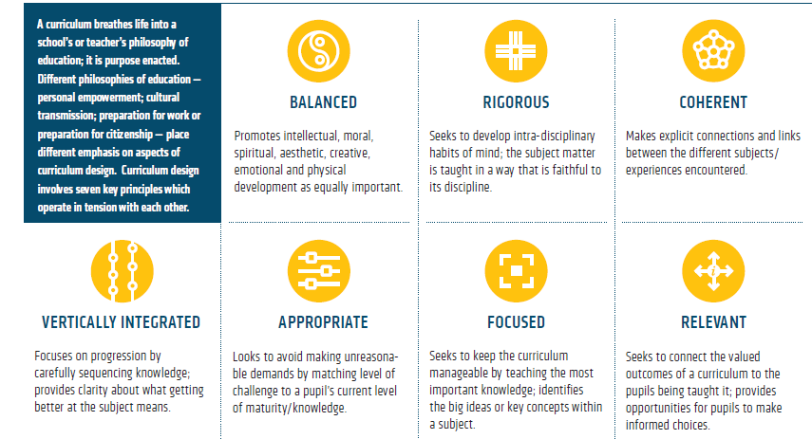

Wiliam D. (2013) Principled Curriculum Design (Designed by Oliver Caviglioli)

*See Curriculum Long Term Maps*

Whilst we ensure that there is a broad and rich curriculum, we prioritise and regard the mastering of foundational knowledge as crucial in the younger years. Reading and vocabulary development is an integral part of our curriculum. We aim to develop Tier 1, 2 and 3 vocabulary (Isabel Beck 2002). Pupils from all backgrounds, including those who are disadvantaged, are provided with the tools to access a broad curriculum within a language rich environment.

We also aim for our curriculum to develop attitudes, attributes and dispositions which enable our children to:

1. develop as confident, responsible citizens;
2. be prepared for future learning e.g. resilience, perseverance and a growth mind-set.

Our curriculum reflects our local needs and context. The curriculum meets the particular aims and values of our school by providing opportunities and experiences for our pupils to develop:

* as 21st century citizens preparing for a successful future through developing a love of learning underpinned by core skills of creativity, perseverance and responsibility.
* as independent critical thinkers who can collaborate and work as part of a team within an inclusive community where everyone is respected and valued for their individual talents and differences.
* Wider horizons for our pupils and raise aspirations through developing knowledge and understanding our local and global environments in the past, present and future.

**Curriculum Implementation:**

‘Learning is defined as an alteration in long-term memory. If nothing has been altered in long-term memory then nothing has been learned.’

Sweller et al. 2011

In line with cognitive load theory we aim, through our teaching, to develop understanding by building well-developed schema: well organised, connected knowledge as opposed to a handful of unconnected facts. We, therefore, favour spaced and distributed learning, where knowledge is rehearsed for short periods over a longer period of time. We aim to ensure retrieval practice is built in to strengthen memory by:

* Providing overviews
* Outlining content to be covered and signalling transitions between different parts of the lesson;
* Calling attention to main ideas;
* Providing daily, weekly and monthly reviews.
* Re-teaching when necessary.

We regard teaching as effective when underpinned by Rosenshine’s ‘Principles of Instruction’ (see the Trust’s Teaching and Learning statement). Effective questioning, effective use of formative assessment and adaptive, responsive teaching are regarded as key.

We regard the following teachers’ knowledge as essential:

* pedagogical knowledge: teachers’ knowledge of effective teaching methods;
* content knowledge: teachers’ subject knowledge;
* pedagogical content knowledge: teachers’ knowledge of how to teach the particular subject / topic e.g. knowing the misconceptions that arise prior to teaching specific key knowledge.

Leadership of the curriculum is distributed within our academies. Subject leaders are given the autonomy to lead on their specific subject curriculum within the shared vision and accountability framework of the school.

**Curriculum Impact**

We measure this by the extent to which our aims, curriculum defined end points and strong outcomes are achieved as a result of our curriculum intent and implementation.

The vast majority of our pupils will have sustained mastery of key, detailed knowledge identified and some children will have a greater depth of understanding.

‘If a student has learnt the curriculum, they have made progress.’

Michael Fordham

**Curriculum Leadership**

Leadership of the curriculum is distributed. Subject leaders are given the autonomy to lead on their specific subject curriculum within the shared vision and accountability framework of the school.